COMPUTER NETWORKS
Week 2 — Structured Study Notes
Instructor: D. MSI
Topics: PPP · ATM · IEEE 802 Standards · CSMA/CD · Token Bus · Token Ring

1 | The Data Link Layer in the Internet

1.1 Overview
The Internet is a large network made of individual machines. These machines are called hosts (like your laptop) and routers (devices that forward data). All these machines are connected using a communication infrastructure.

- Some machines are connected through a LAN (Local Area Network) — for example, computers in a university lab.
- Other machines are connected through point-to-point lines — for example, two cities connected through a cable.
- Point-to-point lines are especially used when machines are far apart.

1.2 When Are Point-to-Point Lines Used?
Point-to-point lines are used in two main situations:

- Situation 1: One LAN connecting to another LAN. This connection acts like a leased line (a dedicated private cable between two places).
- Situation 2: A home user connecting to the Internet using a dial-up connection. This also works like a leased line.

In both situations, a special protocol is used to send data. On the Internet, this protocol is called PPP (Point-to-Point Protocol).

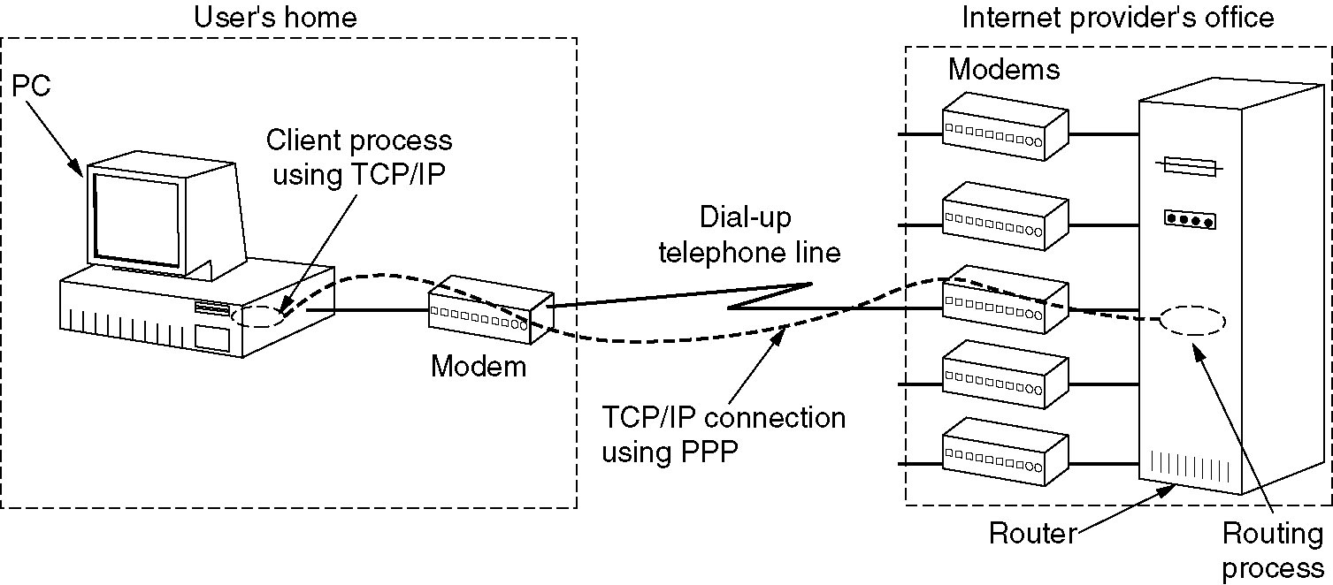

📝 EXAM TIP
Point-to-point lines use PPP as the data link protocol in the Internet.
Know both situations where point-to-point lines are used (LAN-to-LAN, and home dial-up).

2 | PPP — Point-to-Point Protocol

PPP is the standard protocol used for direct connections between two devices (point-to-point links). For example, when your home router connects to your ISP's router, PPP is used.

📌 BACKGROUND: What is HDLC?
HDLC stands for High-Level Data Link Control. It is a data link layer protocol that defines how frames (units of data) are structured and transmitted.
PPP is based on the HDLC frame format. This means PPP uses the same flag byte (01111110) and similar frame structure as HDLC.
HDLC supports three frame types: Information frames (I), Supervisory frames (S), and Unnumbered frames (U). PPP operates in unnumbered mode by default.

2.1 Three Key Features of PPP
PPP provides three important features:

- Framing Method: PPP defines exactly how a frame (a packet of data) is built. The frame format also includes error detection to check if data was received correctly.
- LCP — Link Control Protocol: LCP is responsible for setting up the link, testing it, and closing it when communication is done. It manages the lifecycle of the connection.
- NCP — Network Control Protocol: NCP negotiates (agrees on) options for the network layer. There is a separate NCP for each network layer protocol that PPP supports — for example, one NCP for IP, one for IPX, and one for AppleTalk.

2.2 PPP Frame Format
Every PPP frame (packet) is made of several fields. All PPP frames use the unnumbered mode, which means there are no sequence numbers and no acknowledgements by default.

PPP Frame Structure
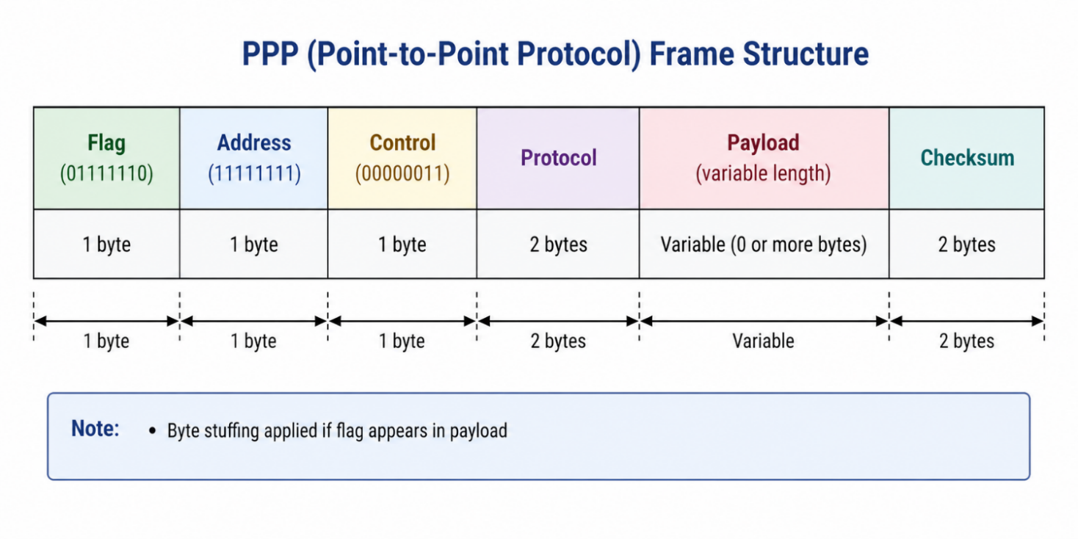

Here is what each field means:

Field | Size / Value | What It Does
Flag | 1 byte = 01111110 | Marks the start and end of every PPP frame. This is the standard HDLC delimiter. If this pattern appears inside the frame data, byte stuffing is applied to avoid confusion.
Address | 1 byte = 11111111 | Always set to broadcast (all ones). This means all stations on the link accept the frame. It removes the need to assign separate addresses on a point-to-point link.
Control | 1 byte = 00000011 | Indicates that this is an unnumbered frame. In unnumbered mode, PPP does not use sequence numbers or acknowledgements by default.
Protocol | 2 bytes (variable) | Tells the receiver what type of data is in the payload. If the first bit is 0, the payload is a network layer packet (e.g., IP or IPX). If the first bit is 1, the payload is a control message (e.g., LCP or NCP).
Payload | Up to 1500 bytes | The actual data being sent. The maximum size can be negotiated. If no maximum is agreed, the default is 1500 bytes.
Checksum | 2 bytes (default) | Used to detect errors in the frame. The checksum size can be negotiated up to 4 bytes for better error detection.

📝 EXAM TIP
The PPP flag byte is 01111110 (same as HDLC).
Address is always 11111111 — it means broadcast.
Control is always 00000011 — unnumbered mode means no ACKs and no sequence numbers.
Protocol starting with 0 = network layer (IP). Starting with 1 = control (LCP/NCP).
Default payload = 1500 bytes. Default checksum = 2 bytes.

2.3 PPP Phase Diagram (How a Connection Is Made and Closed)
A PPP connection goes through several phases (steps). These phases describe what happens from the moment two devices decide to connect, until the connection is closed.

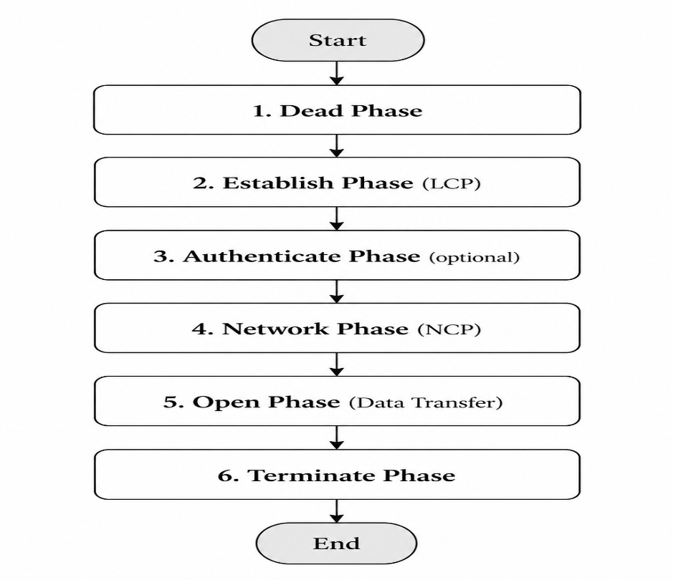
PPP Phase Diagram

Phase | What Happens
Dead | The link is not being used. Nothing is happening.
Establish | LCP (Link Control Protocol) opens and sets up the link.
Authenticate | Optional step. The identity of both sides is verified.
Network | NCP negotiates options for the network layer (e.g., IP settings).
Open | Data is now being transferred between the two sides.
Terminate | LCP closes the link. Connection ends.

2.4 LCP Frame Types
LCP (Link Control Protocol) uses different types of frames to manage the link. Below is a complete reference of all LCP frame types:

LCP Frame Type | Purpose
Configure-Request | Sent to start configuring the link.
Configure-Ack | Confirms that all requested options are accepted.
Configure-Nak | Some options are not accepted; new values suggested.
Configure-Reject | Requested options are completely rejected.
Terminate-Request | Requests to close the link.
Terminate-Ack | Confirms that the link has been closed.
Code-Reject | The received code is unknown or unsupported.
Protocol-Reject | The protocol in the packet is not supported.
Echo-Request | Sent to test if the link is working.
Echo-Reply | Reply to the Echo-Request; confirms link is alive.
Discard-Request | Used only for testing; the receiver discards it.

💡 KEY POINT
LCP frames are used to ESTABLISH, CONFIGURE, TEST, and CLOSE a PPP connection.
Echo-Request and Echo-Reply are used to check if the link is still alive — similar to a 'ping'.
Configure-Nak and Configure-Reject both say 'no', but Nak suggests an alternative, while Reject refuses completely.

3 | Data Link Layer in ATM (Asynchronous Transfer Mode)

3.1 What is ATM?
ATM stands for Asynchronous Transfer Mode. It is a networking technology that transfers data in small, fixed-size packets called cells.

- In normal networking (ISO-OSI model), Layer 2 (Data Link Layer) transfers data in units called frames. Frames can be different sizes.
- In ATM, the transfer unit is called a cell. All cells are exactly the same size — 53 bytes.
- A cell = 5 bytes of header + 48 bytes of payload (actual data).
- The choice of 48 bytes for the payload was a political decision, not a purely technical one. (Different countries had different preferences, and 48 was agreed as a compromise.)

3.2 ATM Cell Structure

ATM Cell Structure (53 bytes total)
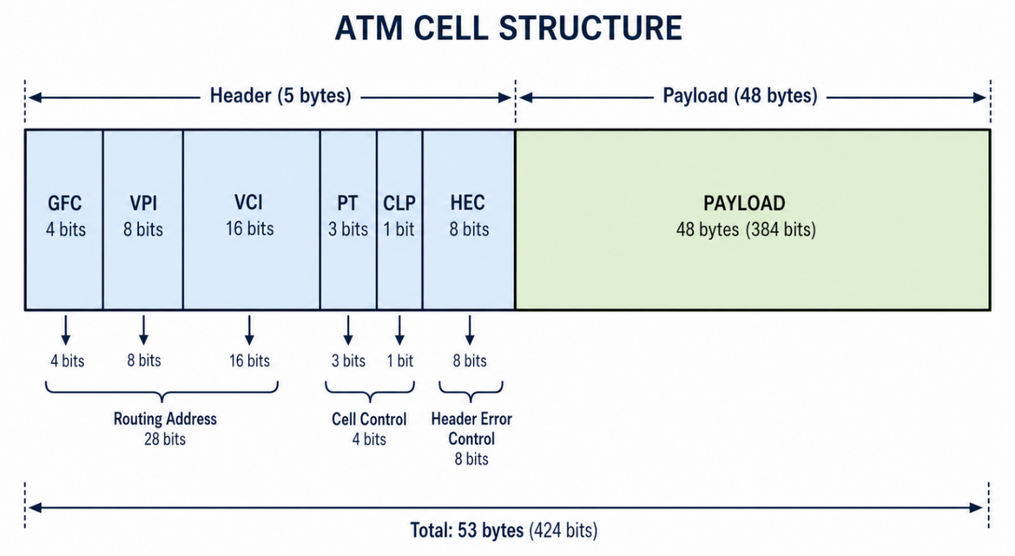

3.3 UNI vs. NNI Cell Formats
ATM defines two different cell formats depending on where the cell is being used:

- UNI (User-Network Interface): Used between a user's device (like a computer) and the ATM switch. This is the most common format. The header has a 4-bit GFC field.
- NNI (Network-Network Interface): Used between two ATM switches inside the network. The GFC field is removed and the VPI field is increased to 12 bits for more routing flexibility.

3.4 ATM Header Fields — Detailed Explanation

Field | Size | Description
GFC (Generic Flow Control) | 4 bits (UNI only) | Controls local data flow between users. Default value is 0000 (four zeros). Not used in NNI.
VPI (Virtual Path Identifier) | 8 bits (UNI) / 12 bits (NNI) | Identifies the virtual path the cell belongs to. Used together with VCI to route the cell.
VCI (Virtual Channel Identifier) | 16 bits | Identifies the specific virtual channel. Together with VPI, it guides the cell through ATM switches to its destination.
PT (Payload Type) | 3 bits | Tells whether the cell carries user data or OAM (management) information.
CLP (Cell Loss Priority) | 1 bit | If set to 1, this cell may be dropped during network congestion. Used to mark low-priority cells.
HEC (Header Error Control) | 8 bits | A CRC (error-checking code) that checks the header for errors. Also helps locate cell boundaries.

3.5 Key Field Descriptions (From Slides)

- GFC: Reserved in UNI for local flow control and sub-multiplexing between users. Not present in NNI.
- VCI and VPI: These two fields work together to identify the route a cell should take through ATM switches on the way to its final destination.
- PT: The Payload Type field is used for OAM (Operations, Administration, and Management) purposes to distinguish data cells from management cells.
- CLP: The network can drop cells or mark them as redundant based on the CLP bit. If CLP = 1, the cell has low priority and may be discarded during congestion.
- HEC: Uses a CRC algorithm to check the header for errors. It also helps locate the boundaries between cells in the data stream — without any extra overhead.

📝 EXAM TIP
ATM cell = 53 bytes = 5-byte header + 48-byte payload.
Know the difference between UNI (user to switch) and NNI (switch to switch).
GFC is only in UNI. NNI uses a larger VPI (12 bits vs. 8 bits).
CLP = 1 means the cell can be dropped. CLP = 0 means keep it.
HEC checks only the header, not the payload.

4 | Why Standardization? — IEEE 802 Standards

4.1 The Problem — Why Were Standards Needed?
Before standards existed, every company or carrier designed its own networking system. This created several problems:

- No compatibility between different systems — devices from different companies could not communicate.
- No mass production was possible — manufacturers could not make one product that worked everywhere.
- Prices stayed very high — without large-scale production, costs could not be reduced.
- Adoption was very low — few people bought expensive, incompatible systems.

The solution was to create a standards committee. The IEEE (Institute of Electrical and Electronics Engineers) was asked to form a committee made up of experts from companies and universities to create a common standard.

4.2 The IEEE 802 Standard
The IEEE organized standards using a numbering system called IEEE 802.x, where x is a number assigned to each working group.

- Example: Work on a broadband wireless standard began in July 1999. The next available number at that time was 802.16, so the standard was named IEEE 802.16 (WiMAX).

📌 Note on Working Group Status (from Slides)
Some IEEE 802 working groups are still active. Some are 'hibernating' (paused but not disbanded). One group gave up and disbanded itself.
For exam purposes, focus on the important ones: 802.3 (Ethernet), 802.11 (Wi-Fi), 802.4 (Token Bus), 802.5 (Token Ring), and 802.16 (WiMAX).

4.3 IEEE 802 Subgroups — Complete Reference

Standard | Responsibility
802.1 | Internetworking
802.2 | Logical Link Control (LLC)
802.3 | Ethernet (CSMA/CD)
802.4 | Token Bus LAN
802.5 | Token Ring LAN
802.6 | Metropolitan Area Network (MAN)
802.7 | Broadband Technical Advisory Group
802.8 | Fiber-Optic Technical Advisory Group
802.9 | Integrated Voice and Data Networks
802.10 | Network Security
802.11 | Wireless Networks (Wi-Fi)
802.12 | Demand Priority Access LANs (e.g., 100BaseVG-AnyLAN)
802.16 | Broadband Wireless (WiMAX)

4.4 Wireless LAN — IEEE 802.11 Protocol Comparison
IEEE 802.11 covers wireless networking (Wi-Fi). There are several versions, each with different speeds and frequencies:

Standard | Max Speed | Frequency | Modulation
802.11 (original) | 1–2 Mbps | 2.4 GHz | FHSS and DSSS
802.11a | 54 Mbps | 5 GHz | OFDM (Orthogonal Frequency Division Multiplexing)
802.11b | 11 Mbps | 2.4 GHz | DSSS (Direct Sequence Spread Spectrum)
802.11g | 20+ Mbps / 108 Mbps (Extreme G) | 2.4 GHz | DSSS / OFDM
802.11n | Higher than 802.11g | 2.4 GHz and 5 GHz | MIMO + OFDM

💡 KEY POINT
802.11a uses 5 GHz, which means less interference but shorter range.
802.11b and 802.11g use 2.4 GHz, which is more crowded but travels further.
802.11n uses both frequencies and MIMO (multiple antennas) for the highest speed.
OFDM = Orthogonal Frequency Division Multiplexing. It sends data on many small sub-frequencies at the same time.

5 | IEEE 802.3 — CSMA/CD (Ethernet)

5.1 What Is CSMA/CD?
CSMA/CD stands for Carrier Sense Multiple Access with Collision Detection. It is the method that Ethernet networks use to share a common communication bus (cable) among many devices.

- CSMA/CD is used extensively in bus LANs (Ethernet).
- It has two parts: the CSMA component and the CD component.

5.2 The CSMA Component (Carrier Sense Multiple Access)
The CSMA component controls when a station is allowed to start transmitting. Here are the steps:

- A station checks the bus to see if any other station is already sending data. (This is called 'carrier sense'.)
- If the bus is free (no traffic), the station starts transmitting immediately.
- If the bus is busy (someone else is sending), the station waits for a random period of time and then tries again.

5.3 The CD Component (Collision Detection)
Even though stations check the bus before sending, two stations might check at exactly the same time and both find the bus free. This causes a collision. Here is how CD handles it:

- Two stations both find the bus free at the same moment.
- Both stations start transmitting at the same time.
- Their signals collide on the bus.
- The CD component detects this collision.
- Both stations are informed of the collision and immediately stop sending.
- Each station waits a random amount of time and then tries to transmit again.

CSMA/CD Operation
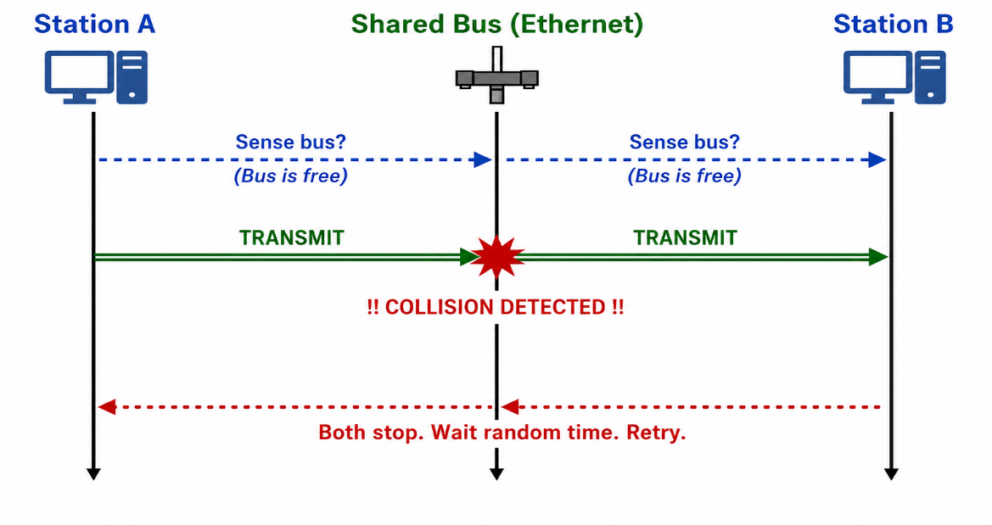

5.4 IEEE 802.3 Speed Standards
CSMA/CD (Ethernet) has been standardized at different speeds:

IEEE Standard | Speed
IEEE 802.3 | 10 Mbps (Ethernet)
IEEE 802.3u | 100 Mbps (Fast Ethernet)
IEEE 802.3z | 1 Gbps (Gigabit Ethernet)
IEEE 802.3ab | 10 Gbps (Ten-Gigabit Ethernet)

📝 EXAM TIP
CSMA = Listen before you speak. CD = Stop if collision happens.
Know the two steps: check bus (CSMA), detect collision and wait (CD).
IEEE 802.3 is standard Ethernet at 10 Mbps. 802.3u = Fast Ethernet (100 Mbps).
CSMA/CD is used in BUS topology networks.

6 | IEEE 802.4 — Token Bus Protocol

6.1 What Is Token Bus?
Token Bus is a LAN protocol where a special control packet called a token is passed from one station to another on a shared bus. Only the station that holds the token is allowed to send data. This prevents collisions entirely.

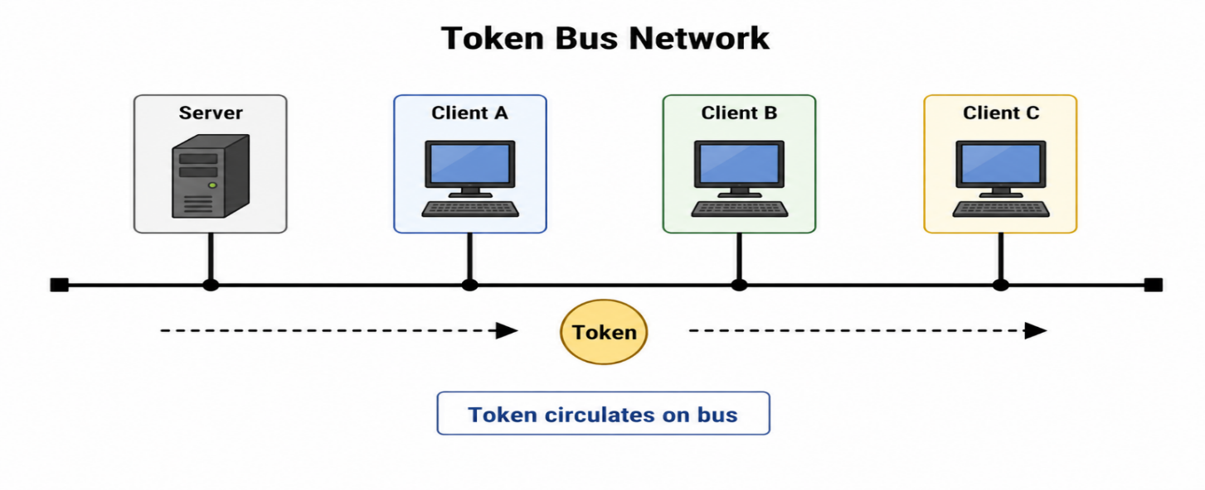

6.2 How Token Bus Works — Data Pickup (Step-by-Step)
When a station wants to send data, here is what happens:

- A token is sent from one node to the next on the bus.
- The client (station) that wants to send data grabs the token when it arrives (if the token is empty).
- The client attaches its data to the token.
- The token (with data attached) travels along the bus until it reaches the destination address.

6.3 How Token Bus Works — Data Delivery (Step-by-Step)
Once the token reaches the destination, here is what happens:

- The token delivers the data to the receiving node.
- The receiver sends an acknowledgement back to the sender.
- The token is then passed on to the next node in the sequence.
- The process continues for every node on the bus.
- If there is an error — a retransmission request is attached to the token and sent back to the original sender.

💡 KEY POINT
In Token Bus, only the token holder can transmit. This eliminates collisions completely.
Token Bus uses a physical bus, but the token passes in a logical ring order.
If a station has no data to send, it simply passes the token to the next station.

📝 EXAM TIP
Token Bus = IEEE 802.4.
The token prevents collisions — only the token holder can transmit.
Know all the steps for both data pickup and data delivery.
Error handling: retransmission request is attached to the token.

7 | IEEE 802.5 — Token Passing (Token Ring) Protocol

7.1 Overview
Token Passing (or Token Ring) is a LAN protocol where devices are connected in a ring. A special control packet called a token circulates continuously around the ring. Only the station that holds the token is allowed to transmit data. This means there are no collisions.

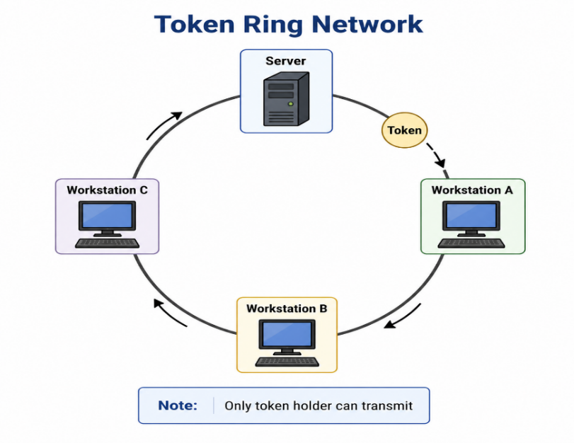

7.2 What Is the Token?
The token is a special data packet with the following properties:

- It can carry data when a station attaches data to it.
- It circulates continuously around the ring — it never stops moving.
- Each workstation and server gets a chance to transmit in turn — fair access for all.

7.3 How Transmission Works — Step-by-Step
When a workstation wants to send data:

- The workstation waits for a free token to arrive (a token that is not carrying any data).
- When a free token arrives, the workstation attaches the following information to it:
  - Sender's address (source)
  - Receiver's address (destination)
  - Data block to be transmitted
  - Error-checking details (e.g., CRC)
- The token (now carrying data) travels around the ring until it reaches the destination device.

7.4 At the Receiving End
When the token with data arrives at the destination:

- The destination station reads the data and checks it for errors.
- If data is received without errors — the station sends a normal acknowledgement back to the sender.
- If data is received with errors — the station reports the error and may request retransmission.

7.5 Where Is Token Passing Used?

- Primarily used in ring LANs — especially the IBM Token-Ring LAN.
- Also used in some bus LANs — called Token-Bus networks (IEEE 802.4).
- Used in large fiber-optic backbone networks (FDDI protocol).
- Used for constructing very large networks that need fair and collision-free access.

7.6 Token Passing Standards

Standard | Usage
IEEE 802.5 | Token-Ring LANs
IEEE 802.4 | Token-Bus LANs
FDDI | Large Fiber-Optic Ring Backbone Networks

📝 EXAM TIP
Token Ring = IEEE 802.5. Token Bus = IEEE 802.4. FDDI = Fiber-optic rings.
Token passing guarantees NO COLLISIONS — the token ensures only one station transmits at a time.
A token carries: sender address + receiver address + data + error-checking info.
FDDI is used for large, high-speed fiber-optic networks.

8 | Quick Reference Glossary

The table below provides a quick reference for all key terms used in this week's content.

Term | Full Form | Simple Meaning
PPP | Point-to-Point Protocol | A data link protocol used for direct connections between two devices.
LCP | Link Control Protocol | Part of PPP. Sets up, tests, and closes the link.
NCP | Network Control Protocol | Part of PPP. Negotiates settings for network layer protocols.
ATM | Asynchronous Transfer Mode | A cell-based networking technology that uses fixed 53-byte cells.
UNI | User-Network Interface | ATM cell format used between a user device and an ATM switch.
NNI | Network-Network Interface | ATM cell format used between two ATM switches.
CSMA/CD | Carrier Sense Multiple Access / Collision Detection | Ethernet's method to share the bus and handle collisions.
FDDI | Fiber Distributed Data Interface | A high-speed fiber-optic ring network standard.
FHSS | Frequency Hopping Spread Spectrum | A wireless technique that hops between frequencies.
DSSS | Direct Sequence Spread Spectrum | A wireless technique that spreads data over a wide frequency.
OFDM | Orthogonal Frequency Division Multiplexing | A modulation method used in Wi-Fi for high-speed data.
OAM | Operations, Administration, and Management | Network management functions in ATM.
HEC | Header Error Control | CRC check on the ATM cell header.
CLP | Cell Loss Priority | 1-bit ATM field; if set, the cell can be dropped during congestion.
MIMO | Multiple Input Multiple Output | A wireless technique using multiple antennas to improve speed.

9 | Comparison: LAN Protocols at a Glance

Use this table to quickly compare the main LAN protocols covered in Week 2:

Protocol | IEEE Standard | Topology | Access Method | Collision? | Key Feature
Ethernet | 802.3 | Bus | CSMA/CD | Yes (detected) | Listen before sending; detect and recover from collisions.
Token Bus | 802.4 | Bus | Token Passing | No | Token circulates on bus; only token holder can send.
Token Ring | 802.5 | Ring | Token Passing | No | Token circulates in ring; fair access for all stations.
Wi-Fi (original) | 802.11 | Wireless | CSMA/CA* | Avoided | Uses FHSS or DSSS spread-spectrum techniques.
ATM | N/A (own) | Point-to-Point / Switched | Cell Switching | No | Fixed 53-byte cells; very fast and predictable.

* CSMA/CA = Carrier Sense Multiple Access with Collision Avoidance (used in wireless — not covered in this week's slides but mentioned for completeness).

✏ | Final Exam Quick Notes

Top 10 Things to Remember for the Exam
1. PPP flag byte = 01111110 | Address = 11111111 | Control = 00000011 (unnumbered mode).
2. PPP Protocol field: starts with 0 = network layer (IP), starts with 1 = control (LCP/NCP).
3. PPP Phases (in order): Dead → Establish → Authenticate → Network → Open → Terminate.
4. ATM cell = 53 bytes = 5 header + 48 payload. Size was a political compromise.
5. ATM UNI = user to switch. NNI = switch to switch. GFC only in UNI.
6. ATM CLP = 1 means cell can be dropped during congestion.
7. IEEE 802.3 = Ethernet (CSMA/CD). IEEE 802.11 = Wi-Fi. IEEE 802.16 = WiMAX.
8. CSMA/CD = Listen before sending + Stop and retry if collision occurs.
9. Token Bus (802.4) and Token Ring (802.5) both prevent collisions using a token.
10. FDDI = high-speed fiber-optic ring backbone (uses token passing).

